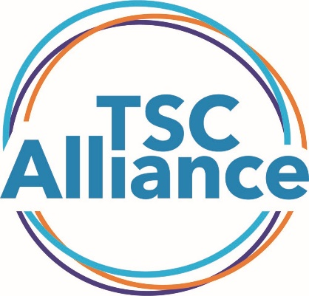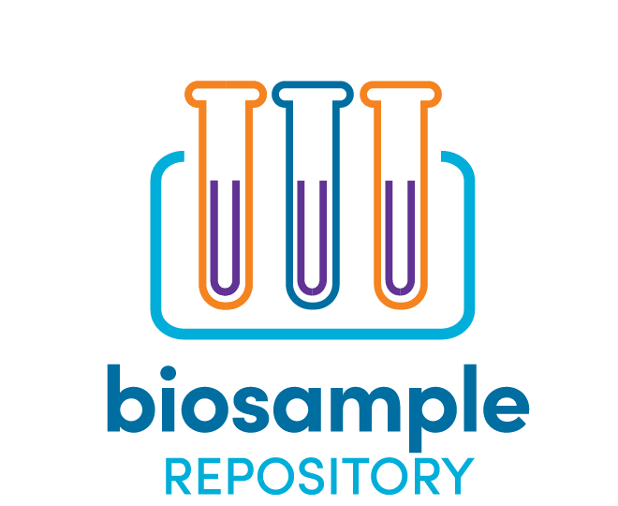
APPLICATION FOR BIOSAMPLE ACCESS
Purpose
Please submit this Application for Biosample Access if you meet both of the following criteria:
- You are an investigator with funding and resources in place for a defined study, and
- You are ready to request specimens from the TSC Biosample Repository.
If you do not yet have funding and require a letter documenting the availability of specimens to include with your funding application, do not submit this form. Instead, please write a one-page Letter of Intent describing your research project, the need for biosamples from the repository, and the potential impact of your project on the TSC community. We encourage investigators who are applying for funding to correspond with TS Alliance staff as early as possible to determine whether the TSC Biosample Repository has the specimens they need.
Process
Applications are accepted on a rolling basis. After an administrative review by TS Alliance staff, the Natural History Database and Biosample Repository Steering Committee will review the application in accordance with the review criteria within 4 weeks. If a quorum (majority) of the committee approves, the TS Alliance will send a Material Transfer Agreement to the investigator. The Biorepository personnel at the Van Andel Research Institute will work with the investigator to arrange shipment of samples.
When complete, please submit this application along with the following attachments to biosample@tscalliance.org.
Attachments
☐Investigator CV or NIH-style Biosketch
☐IRB Approval (or exemption) letter
Attach a copy of your Institutional Review Board (IRB) approval letter for this project. Please ensure the letter includes the project title. If your project has been determined to be exempt, please attach a letter from an appropriate official (IRB chair, department chair, etc.) other than the PI stating your proposed use of human samples is authorized and universal precautions will be observed during handling.
Please ensure that your IRB approval or exemption will allow you to use biosamples and natural history data collected for the TSC Biosample Repository and TSC Natural History Database projects. If you have any questions about your IRB approval, please contact biosample@tsalliance.org.
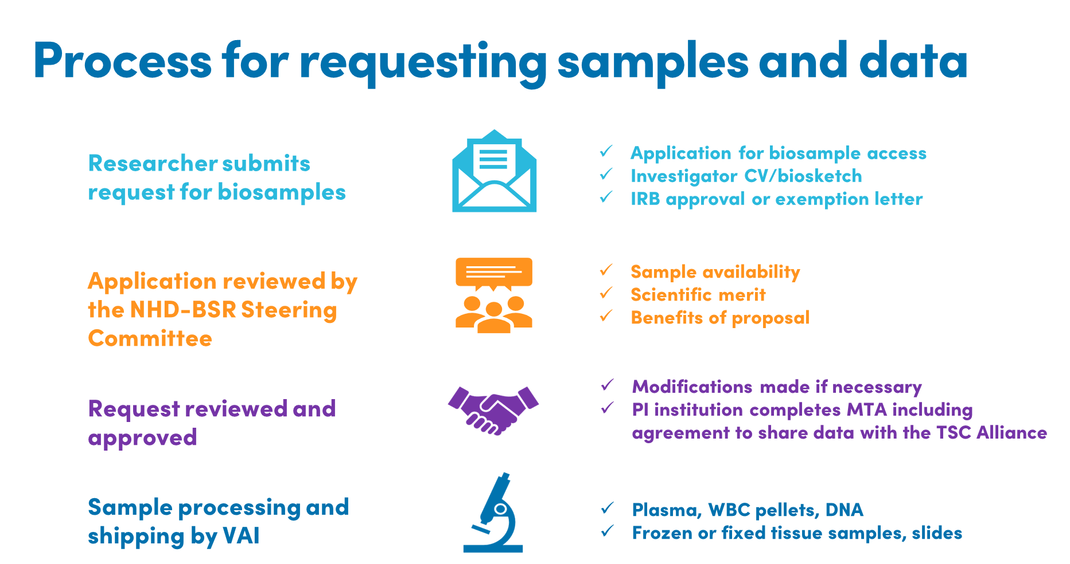
Application Form
PRINCIPAL INVESTIGATOR INFORMATION

Date of Request:

First Name: Middle Name: Last Name:
Salutation: Degree: Title:
Phone #: Alt. Phone #:
Email: Fax #:

Mailing Address
Institution: Department:
Address 1: Address 2:
City: State: Zip Code:
Country: Institution’s Federal Congressional District:
Funding Source(s) to support the proposed work, including specific award numbers:

SHIPPING INFORMATION

Lab Contact/Recipient
Same as PI Information
First Name: Middle Name: Last Name:
Salutation: Degree: Title:
Phone #: Alt. Phone #:
Email: Fax #:

Mailing Address
Same as PI Information
Institution: Department:
Address 1: Address 2:
City: State: Zip Code:
Country:

STUDY INFORMATION
Study Title:
Abstract/Summary of Study (limit to ½ page):
Specific Aims (2-3 sentences):
Long-Term Study Objectives (including impact to the TSC community; 2-3 sentences):
Experimental Design and Methods:
Justification for Numbers (volume or quantity of samples requested; include statistical power analysis, if applicable):
How soon will you use the biosamples, once received?
Along with the biosamples, you will be entitled to receive any data generated by other investigators using these samples. In return, you are required to share data generated on each sample with the TSC Biosample Repository. Data can be embargoed for a period to be defined in the Material Transfer Agreement to provide time to publish, protect intellectual property, etc.

Describe any other ways you plan to share the data, results, and resources that are generated:

Specific data elements that will provided back to the TSC Biosample Repository for each sample analyzed:

REQUEST INFORMATION: DONOR DETAILS
Donor Demographics
Sex: Male Female Either
Race: Any American Indian or Native American Asian African American
Nature Hawaiian/Other Pacific Islander White Multi-Racial Unknown
Ethnicity: Not Hispanic or Latino Hispanic or Latino Any
Age Range: Minimum: Maximum:
Donor Clinical History (please list any inclusion and exclusion requirements):
Total number of donors requested:

SAMPLE PREPARATION DETAILS
BLOOD PREP TYPE
Plasma Volume: mL µL
White Blood Cell Pellets Number of cells per sample:
Other (please explain):

NUCLEIC ACID – FROM BLOOD
DNA RNA
Minimum Quantity: Maximum Quantity:
Minimum Concentration: Maximum Concentration:
Minimum Volume: mL µL

NUCLEIC ACID – FROM BUCCAL SWABS
DNA RNA
Minimum Quantity: Maximum Quantity:
Minimum Concentration: Maximum Concentration:
Minimum Volume: mL µL

NUCLEIC ACID – FROM TISSUE
DNA RNA
Minimum Quantity: Maximum Quantity:
Minimum Concentration: Maximum Concentration:
Minimum Volume: mL µL

TISSUE
Fresh Frozen FFPE
Tissue Curls Thickness: Number of curls:
Glass Slides # Unstained: #H&E Stained:

OTHER PREPARATION DETAILS
Please describe. Include specifics, as appropriate:
Any other considerations we should be aware of?

NATURAL HISTORY DATABASE DATA
Will your project also use data stored in the Natural History Database?
YES
NO

If YES, please fill out the NHD Data Request Form along with your application for biosample access.

